Pupil premium strategy statement – Cantrell Primary School

This statement details our school’s use of pupil premium funding to help improve the attainment of our disadvantaged pupils.
It outlines our pupil premium strategy, how we intend to spend the funding in this academic year and the outcomes for disadvantaged pupils last academic year.

School overview
Detail | Data
Number of pupils in school | 361
Proportion (%) of pupil premium eligible pupils | 35.4%
Academic year/years that our current pupil premium strategy plan covers (3-year plans are recommended – you must still publish an updated statement each academic year) | 2025/2026 – 2027/2028
Date this statement was published | November 2025
Date on which it will be reviewed | July 2026
Statement authorised by | D Weaver
Pupil premium lead | J Tomkinson  S Bagnall  S DeBarr  C Langham
Governor / Trustee lead | Ruth Palmer

Funding overview
Detail | Amount
Pupil premium funding allocation this academic year | £186,345
Pupil premium funding carried forward from previous years (enter £0 if not applicable) | £0
Total budget for this academic year  If your school is an academy in a trust that pools this funding, state the amount available to your school this academic year | £186,345

Part A: Pupil premium strategy plan

Statement of intent
At Cantrell Primary School, we are committed to ensuring that every child, regardless of their background, has access to a high-quality education and opportunities to thrive. Situated in a vibrant and diverse community, our school serves an area where many families face significant social and economic challenges. These challenges can create barriers to learning and limit the life chances of some of our children.
At Cantrell Primary School staff believe in all children and their ability to achieve; there are no excuses made for under performance. Instead, all adults adopt an approach which searches for solutions, encouraging children to do the same.
We adopt a whole school approach in which all staff take responsibility for disadvantaged pupils’ outcomes and raise expectations of what they can achieve. We will focus on diminishing differences between our disadvantaged pupils and those not in receipt of the funding, both within school and nationally. The usual cycle of data collection and the monitoring and tracking of the cohort’s attainment, will be used to inform pupil progress and enable the early identification of need, support and appropriate intervention.
We support the children to develop a growth mind set and attitude towards learning. Our priority is to ensure that day to day teaching in school continues to improve with increasing percentages of outstanding teaching across the school. Additionally, we also ensure that focused support and strong pastoral care is given to children that require it, so they are able to achieve their full potential.
Cantrell Primary School considers how to allocate the PPG on an annual basis following rigorous data analysis and careful consideration of the needs of all the children within this group. Current evidence-based research such as proven in school data and the EEF (Education Endowment Foundation) is used to inform spending in order to achieve the best outcomes for our children. We have a clear and concise approach to the use of the PPG and plans are integrated into a wider school support. These are monitored and evaluated regularly to ensure the correct support and strategies are identified so pupils can make the best progress possible and that the PPG has the necessary impact on achievement, attendance and pastoral care. Here at Cantrell Primary School, under-performing pupils at all levels are targeted not just lower attaining pupils.

Challenges
This details the key challenges to achievement that we have identified among our disadvantaged pupils.
Challenge number | Detail of challenge
1 | Academic progress and attainment  Pupils eligible for the Pupil Premium grant typically enter school with lower starting points, particularly in Reading, Writing, and Maths. Their prior attainment is below the national average, highlighting the need for targeted support to close these gaps: 40% of EYFS children eligible for PP are at WTS in Reading, Writing and Maths combined.
2 | Communication and language development  On entry, language and communication skills are below age-related expectations particularly those eligible to the pupil premium grant. Poor spoken language impacts pupils’ ability to express themselves, understand instructions, and process information, in order to write coherently using a wider range of vocabulary.
3 | Social, emotional and mental health development  For effective learning to take place, pupils’ social and emotional needs must be met. Children in receipt of the Pupil Premium grant may struggle with engagement, low-level disruption, and disengagement in lessons. Creating a calm, supportive learning environment is essential to help these pupils focus, participate, and thrive academically.
4 | Raising aspirations  Pupils eligible for the Pupil Premium grant often have limited experiences beyond their immediate environment, including access to cultural events, places of interest, and extra-curricular activities due to financial constraints. The curriculum is designed to provide enriching opportunities and raise aspirations by broadening pupils’ understanding of the wider world and future career possibilities.
5 | Attendance and Punctuality  Attendance and Punctuality are key factors which affects the children and much progress has been made on this. For the academic year 2024/25 overall attendance was 94% (90.2% for PP) Overall attendance is on an upward trajectory but the gap between advantaged and disadvantaged children remains.

Intended outcomes
This explains the outcomes we are aiming for by the end of our current strategy plan, and how we will measure whether they have been achieved.
Intended outcome | Success criteria
To narrow the attainment gap between disadvantaged and non-disadvantaged pupils in Reading/Writing/Maths for KS2 outcomes. | In 2024/25 the attainment gap between disadvantaged and non-disadvantaged children was 22% for combined (R/W/M). For Cantrell at KS2, the gap was 21%. However, the gap for other year groups is currently larger than this – the gap should be reduced to be in line or less than National for the year.
To improve the oracy and communication of disadvantaged pupils across the whole curriculum using early intervention and deliberate, explicit and systematic teaching | Talk in classroom is been planned, designed, modelled, scaffolded and structured to enable all learners to develop the skills needed to talk effectively and with confidence.  • There’s deliberate, explicit and systematic teaching of oracy across phases and throughout the curriculum which supports children to make progress in the four strands of oracy.  • A greater proportion of pupil premium pupils are achieving age related expectations in communication and language at the end of EYFS.  • Individual needs are addressed through targeted interventions.  EYFS children eligible for PP recorded at “well below” in the ELG 2024/2025:  Reading 40%  Writing 40%  Listening, attention and understanding: 20%  Speaking 27%
Children’s social, emotional and mental health needs are addressed and they are supported to access learning. | Wider strategies and targeted support help disadvantaged pupils access learning by meeting needs at whole school, class, and individual levels. This leads to improved learning behaviours and greater engagement across the curriculum.
To achieve and sustain improved attendance and punctuality for all pupils, particularly our disadvantaged. | Increased attendance for all pupil premium pupils to close the gap with the expected national figure and to decrease the % of pupil premium pupils who are persistent absentees.  2 term (2024/2025 – IDSR data) – 36.4% compared to national 24.5%.  Insight shows end of year data – 27.4%  Work closely with families to understand the barriers and to lower the percentage of persistent absences and improve punctuality for all children.

Activity in this academic year
This details how we intend to spend our pupil premium funding this academic year to address the challenges listed above.

Teaching (for example, CPD, recruitment and retention)
Budgeted cost: £93,172
Activity | Evidence that supports this approach | Challenge number(s) addressed
Continued use of White Rose to support consistency in teaching and use of high-quality resources in Maths. | The impact of mastery learning approaches is an additional five months progress, on average, over the course of a year.  Mastery learning | EEF  https://www.ncetm.org.uk/teaching-for-mastery/mastery-explained/ | 1
Develop a language rich learning environment | Vocabulary included on planning documents and explicitly referred to across the curriculum.  https://educationendowmentfoundation.org.uk/education-evidence/teaching-learning-toolkit/oral-language-interventions | 1,2,3,4
Embedding of Little Wandle phonics programme including ongoing training, support and resourcing. | The EEF Toolkit states that “phonics approaches have been consistently found to be effective in supporting younger readers to master the basics of reading, with an average impact of an additional four months’ progress.” Educationalists such as Doug Lemov advocate reading as “the gateway to all other curriculum offers” Which means to read, signifying its importance.  High quality programme on DfE recommendation:  https://www.gov.uk/government/publications/choosing-a-phonics-teaching-programme/list-of-phonics-teaching-programme | 1,2,3
Quality first teaching – ongoing employment of teachers and teaching assistants, recognising their further development through CPD including courses, coaching/appraisal process and CPD library. | Quality first teaching is the first strategy to support addressing the needs of all children but is also the greatest way to support those in receipt of the PP grant. To maintain and quality assure QFT to ensure it is of the highest standard, staff need to be retained, progressed and developed through a variety of strategies.  The EEF guide to the Pupil Premium. Education Endowment Foundation. Addressing Educational Disadvantage in Schools and Colleges: The Essex Way Marc Rowland | 1,2,4
Enable children to have access to the school’s own in house qualified counsellor. | Pupils able to receive emotional support from a qualified counsellor within school, giving them a greater opportunity to reach their full potential.  SEMH | 3
Implementation of attendance strategy | The DfE document, ‘Improving school attendance: support for schools and local authorities’ (2021), recommends for schools to: ‘establish and monitor implementation of rewards for attendance and punctuality’ and to: ‘regularly communicate expectations for attendance and punctuality’. The strategies for attendance include regularly rewarding attendance but also developing communication to prevent absence and lateness. | 5
Magic Breakfast Provision | Embedded provision: Our latest audit from Magic Breakfast stated: “It is apparent that staff and pupils are aware of Magic Breakfast. The school is committed to feeding children at risk of hunger. The offer is embedded in the school day”.  Breakfast is available to all target pupils every day and there are no school mandated barriers to access.  Grab and Go on the playground is offered free of charge for everyone including nursery, any late children and available throughout the morning. 86% of pupils are eating breakfast AND target children take up is at least in proportion to number of target pupils in school across all provisions.  “Readiness for Learning” Magic Breakfast research evidence “Overwhelming evidence of the positive impact that eating a nutritious breakfast has on school children. 72% reported improved educational attainment among pupils who attend breakfast club with 81% reporting increased energy levels/alertness and 88% reporting improved concentration levels among pupils.  https://educationendowmentfoundation.org.uk/projects-and-evaluation/projects/magic-breakfast | 3,5
Children have access to experiences and trips which add to their understanding of the world and enhance the richness of their education, increasing aspirational outcomes and cultural capital. | When trips, visits and experiences explicitly addressed curriculum content, they impacted significantly on progression and attainment. (Dr Jane Dudman, Carrie Hedges & Dr Chris Loynes, 2018).  Although assumptions should not be made regarding the experiences of children in receipt of the PP grant, the cost of living crisis suggests that day trips, holidays and general experiences may not be prioritised in many homes. Supporting children in accessing such experiences not only provides an opportunity for them to see beyond their own community but also to allow them develop their cultural capital and future aspirations, impacting on their academic development too. | 4

Targeted academic support (for example, tutoring, one-to-one support, structured interventions)
Budgeted cost: £28,172
Activity | Evidence that supports this approach | Challenge number(s) addressed
Use of social and emotional interventions such as the use of Lego therapy and zones of regulation. | The use of social and emotional interventions within schools is a proactive measure to supporting the children’s mental health and behaviour but can also be used reactively when combined with the use of Leuven’s data for identification. These interventions take part as groups, allowing children to develop their relationships with others and supporting them in understanding themselves better as well as developing their skills of regulation and reflection.  https://educationendowmentfoundation.org.uk/education-evidence/teaching-learning-toolkit/social-and-emotional-learning | 2,3
Interventions used to complement quality first teaching though the use of specialised digital programmes: Times Tables Rock Stars  Dynamo Maths  Mathletics | Spaced learning and retrieval practice are recognised practices which enhance the learning of children. Regular practise/application of skills allows children to develop and consolidate skills taught in main lessons, supporting them in keeping up rather than catching up. | 1,2,3
Careful gaps analysis of assessment followed up by interventions based on analysis.  Smartgrade  Insight | The use of Smartgrade for gaps analysis ensures that the elements which the children complete interventions on are bespoke to them and their needs. Interventions are completed by teachers and TAs who work directly with the class, ensuring that the learning parallels what is taught and thereby enhances rather than detracting from the quality first teaching. Where there are many children needing a specific intervention, then this may be added as a whole class intervention by the teacher, again as a way to enhance the quality first teaching being completed. | 1,2,3,5
Oral language interventions: • Early Talk Boost language intervention delivered in EYFS | EEF toolkit: Evidence shows the average impact of Oral language interventions is approximately an additional six months’ progress over the course of a year. Some studies also often report improved classroom climate and fewer behavioural issues following work on oral language.  https://educationendowmentfoundation.org.uk/edu cation-evidence/teaching-learning-toolkit/oral  language-interventions Early talk Boost evaluation report: On average, children make six months’ progress in their early language development after the nine-week intervention, helping them to narrow the gap between them and other children their age.  https://ican.org.uk/media/2003/early-talk-boost | 1,2

Wider strategies (for example, related to attendance, behaviour, wellbeing)
Budgeted cost: £65,000
Activity | Evidence that supports this approach | Challenge number(s) addressed
In house School Counsellor Pupils are able to receive emotional support form a qualified person enabling a greater opportunity to reach their full potential. | Have an understanding of self-regulation and dealing with difficult and distressing situations.  https://educationendowmentfoundation.org.uk/education-evidence/teaching-learning-toolkit/metacognition-and-self-regulation  https://d2tic4wvo1iusb.cloudfront.net/production/eef-guidance-reports/primary-sel/EEF_Social_and_Emotional_Learning.pdf?v=1731076872 | 1,2,3,5
School Attendance Officer working with families to improve attendance and reduce lateness. New attendance initiatives. | School Attendance Officer helping to support families to maintain the level of attendance expected. “Persistent school non-attendance is associated with child and adult mental health difficulties”.  Attendance recommendations Parent support meetings to be offered if necessary.  Working with parents to improve attendance Late gate and first day absence reporting daily.  Follow the correct protocol for pupil attendance. “Small changes matter”  https://educationendowmentfoundation.org.uk/education-evidence/guidance-reports/supporting-parents  https://assets.publishing.service.gov.uk/media/66bf300da44f1c4c23e5bd1b/Working_together_to_improve_school_attendance_-_August_2024.pdf | 5

Total budgeted cost: £186,345

Part B: Review of the previous academic year

Outcomes for disadvantaged pupils
Intended outcome | Success criteria | Outcomes
Decrease in number of behaviour incidents.  Increase is self-regulation | Staff and pupils have better knowledge of support and strategies in the understanding of their own emotional needs. | Evidence including pupil voice and parent surveys shows a decrease in the number of incidents of low-level disruptive behaviour.  Sustained improvements in well-being.  Reduction in behaviour incidents involving disadvantaged children.
Development of age-appropriate vocabulary and early language skills among disadvantaged pupils | The ability to communicate clearly at an early level. Pupils express their feelings using full sentences with support from their teacher. | 75% (3 out of 4 children) (above national) of Pupil Premium children in EYFS achieved 2 in Communication & Language (July 24).  July 25 showed 60% (9 out of 15 children) of Pupil Premium children in EYFS achieved 2 in Communication and language.  Within the setting each class has a calming and well-being space, where children can access independently or with adult support where necessary. Visual timetable to support self regulation and routines. On entry calming music and breathing techniques are modelled by the adults to encourage the children to be ready for learning.  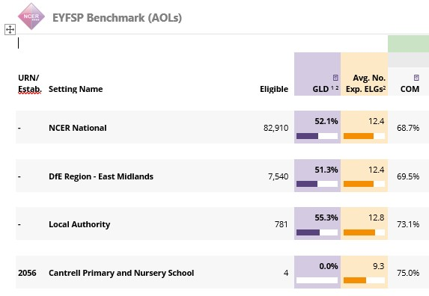
Within the setting adults focus on interacting and modelling language and new vocabulary introduced through story, rhymes, and imaginative play. Language and vocabulary are extended and repeated to embed understanding and use. In addition, where needed
Communication Boards and ‘Now and Next’ also support reach the development of age-related language skills among disadvantaged pupils. Staff have high expectations for all children.
Improved reading attainment for disadvantaged pupil. Narrow the gap between pupil premium and non-pupil premium pupils | Pupil Premium data for KS1 and KS2 reading data will show comparably to that of non-pupil premium pupils and individual the gaps will have narrowed. | 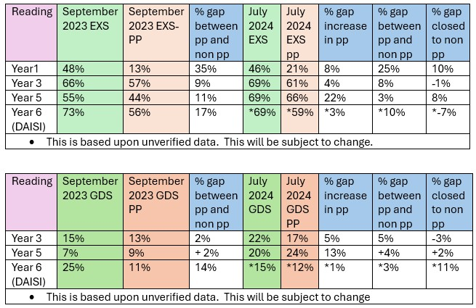  Improved reading attainment: Our latest assessment data (Summer 2024) shows that the Pupil Premium (PP) gap for Reading narrowed for the children.  July 2025  Overall the gap is narrowing year on year; however, due to mobility, percentages vary slightly between data collections e.g. in Years 3 to 4, this formed part of termly pupil progress meetings.
  PP – Reading | Autumn | Spring | Summer
  Year 1 - | 14% | 12% | 38%
  Year 2 - | 29% | 23% | 36%
  Year 3 - | 55% | 52% | 52%
  Year 4 - | 59% | 57% | 56%
  Year 5 - | 45% | 59% | 69%
  Year 6 - | 69% | 68% | 60%
Writing for a purpose and improvement using grammar, punctuation and spelling. | Pupils writing to show improved development. Targeted support planned and taught to small groups. | 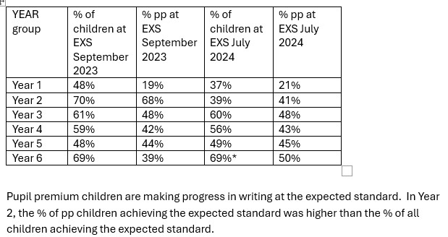  July 2025:  Writing continues to be a school priority
  PP – Writing | Autumn | Spring | Summer
  Year 1 - | 7% | 6% | 24%
  Year 2 - | 21% | 15% | 14%
  Year 3 - | 40% | 38% | 38%
  Year 4 - | 55% | 43% | 43%
  Year 5 - | 36% | 41% | 39%
  Year 6 - | 48% | 54% | 58%
To achieve and sustain improved attendance for all pupils, particularly our disadvantaged. | Increased attendance for all pupils to close the gap with the expected national figure.  Work closely with the school attendance officer to lower the percentage of persistent absences for all children. | July 2024  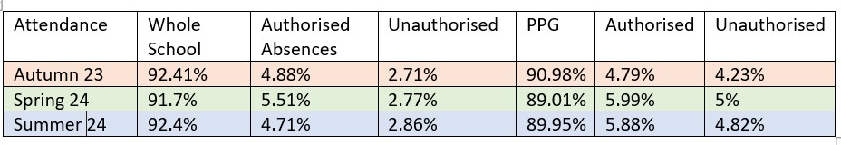  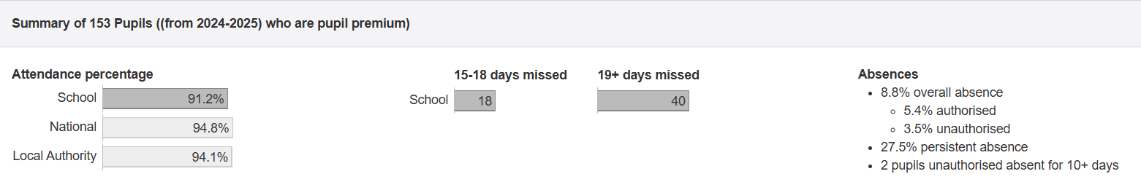  July 2025  For pupils in receipt of the PPG, overall attendance improved by 1.25%. Authorised absence rates improved by 0.48% and unauthorised absence rates improved by 1.32%.

Throughout 2024/25, clear progress was made for disadvantaged pupils. Pupil progress meetings were used effectively to coach teachers in identifying barriers to learning, particularly for pupils eligible for Pupil Premium funding. This informed the implementation of bespoke, targeted academic support and interventions, directly impacting attainment, progress, behaviour and wellbeing

Externally provided programmes
Please include the names of any non-DfE programmes that you used your pupil premium to fund in the previous academic year.
Programme | Provider
Time Table Rock Stars | Maths Circle
White Rose Maths | Maths Hub
Mymaths | Oxford University Press
BSquared | BSquared
Dynamo Maths | Jelly James

Further information (optional)
Use this space to provide any further information about your pupil premium strategy. For example, about your strategy planning, implementation and evaluation, or other activity that you are delivering to support disadvantaged pupils that is not dependent on pupil premium funding.

